FY22FINAL PUBLIC NOTICE
MSD has applied for Federal Emergency Management Agency (FEMA) Flood Mitigation Assistance (FMA) grant program funding through the Kentucky Emergency Management and Homeland Security Agency (KYEM/HS) as a sub-recipient.
Under the National Environmental Policy Act (NEPA), federal actions must be reviewed and evaluated for feasible alternatives and for social, economic, historic, environmental, legal, and safety considerations. Under Executive Order (EO) 11988 and EO 11990, FEMA is required to consider alternatives and provide a public notice of any proposed actions in or affecting floodplains or wetlands. EO 12898 also requires FEMA to provide the opportunity for public participation in the planning process and to consider potential impacts to minority and low-income populations. This notice may also fulfill requirements under Section 106 of the National Historic Preservation Act (NHPA).
Funding for the proposed project will be conditional upon compliance with all applicable federal, tribal, state, and local laws, regulations, floodplain standards, permit requirements and conditions.
Applicant: KYEM/HSA
Project Titles: FMA 2022 Beachland Beach Rd, FMA 2022 Elba Dr, FMA 2022 W Riverside Dr and FMA 2022 Blankenbaker Ln, FMA 2022 Gloria Ln, FMA 2022 Chenoweth Run Rd
Location of Proposed Work:
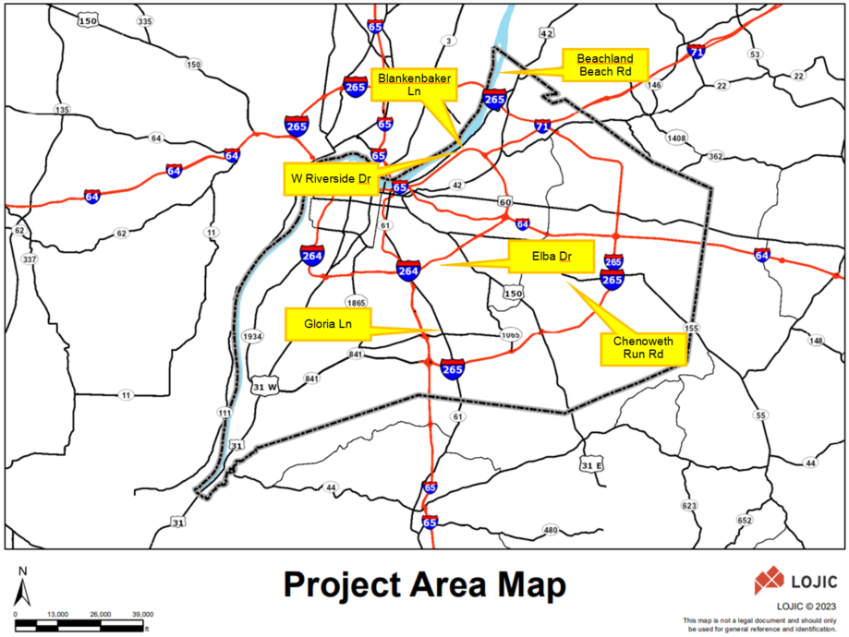

Special Flood Hazard Area Zone: This project is for the demolition of eight residential structures located in flood zone AE (1% annual chance floodplain). Confirmation of location in an SFHA was made by reference to the latest Flood Insurance Rate Maps. The proposed work conforms to all applicable State of Kentucky and local floodplain regulations.

Proposed Work and Purpose:
MSD is requesting funds for a grant project for the purchase and demolition of eight residential structures. The purpose of this project is to remove 3 floodprone, 4 repetitive loss, and 1 severe repetitive loss structures from the floodplain.

Project Alternatives:
Alternative #1 (no action alternative): If no action is taken, the properties will continue to incur damages related to high intensity storms and flooding. The properties are located within the 100-year floodplain and have shown repeated flooding over the past decade, including events that were smaller than 100-year events.

Alternative #2 An alternative considered for this area was to elevate the structures. For this project, the structures would need to be elevated 9.5, 11.6, 11.5, 8.0’, 4.3’, and 4.2’ per local freeboard requirements for FMA 2022 Beachland Beach Rd, FMA 2022 Elba Dr, FMA 2022 W Riverside Dr, FMA 2022 Blankenbaker Ln, FMA 2022 Gloria Ln, and FMA 2022 Chenoweth Run Rd respectively. Estimated costs are calculated based on elevation height, type of elevation, and square footage of the structures. Based on previous experience with elevating structures in the area, we have estimated the cost for elevating the primary structure to exceed the home’s estimated value. In addition, risk would remain for floods greater than the estimated flood heights.

Comment Period:
Comments are solicited from the public, government agencies, and other interested parties in order to consider and evaluate the impacts of the proposed projects. Email comments, requests for additional information about the proposed actions or a copy of the findings to Jennifer Kern with Louisville MSD (Jennifer.Kern@louisvilleMSD.org). All comments are due within 30 days of this notice. MSD will forward comments to applicable regulatory agencies as needed.

POSTED ON: January 31, 2023

End of Notice

